Informatics Laboratory
Junior Project (Databases, Object-Oriented Programming)
User Interface Worksheet

MODUL 7 : USER INTERFACE
Complete the UI layout that was designed in the practical assignment. Make sure that navigation between one form and another can already be performed.

Project and technology
BarengIn - carpooling for university students, matched by class schedule. The UI is a desktop prototype written in C# with Avalonia (cross-platform, runs on macOS and Windows). Every screen is its own form (Window) and uses sample data only. The Login and Find a Ride screens started from Calvin's original Windows Forms version, which is kept in the repository as the reference design.

Screen 1 - Login
Role picker (Passenger or Driver), student ID (NIM), password. Login opens the Passenger Home or the Driver screen depending on the role. 'Create one' opens Register. Close exits.
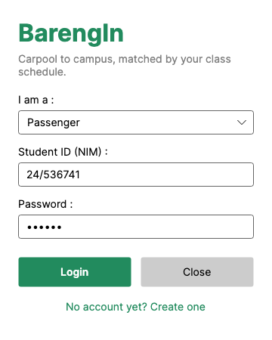
Figure 1. LoginWindow

Screen 2 - Register
Full name, NIM, faculty, password with confirmation and a KTM photo picker. Validation errors are shown in a message box; Back returns to Login.
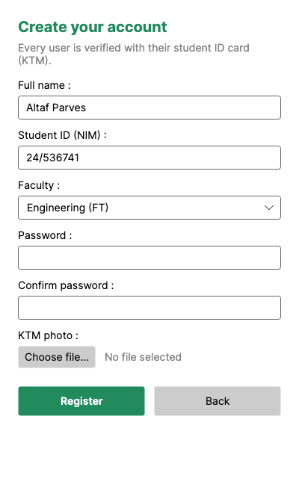
Figure 2. RegisterWindow

Screen 3 - Passenger Home (Find a Ride)
Pickup area, destination faculty and class start time. Find Rides lists matching drivers with the departure time worked out from the class start; Request Ride sends a request and updates the CO2 saved counter. Profile and Logout buttons for navigation.
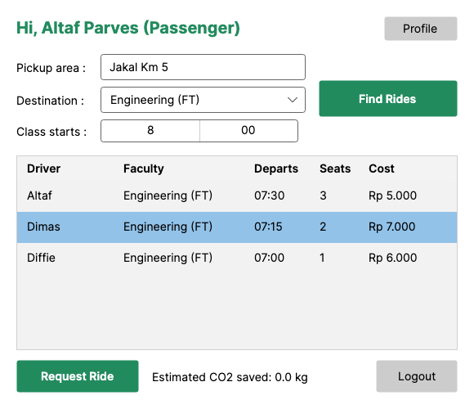
Figure 3. HomeWindow

Screen 4 - Driver
Post a trip (pickup, destination, departure, seats, cost per seat) and review passenger requests with Approve and Reject buttons.
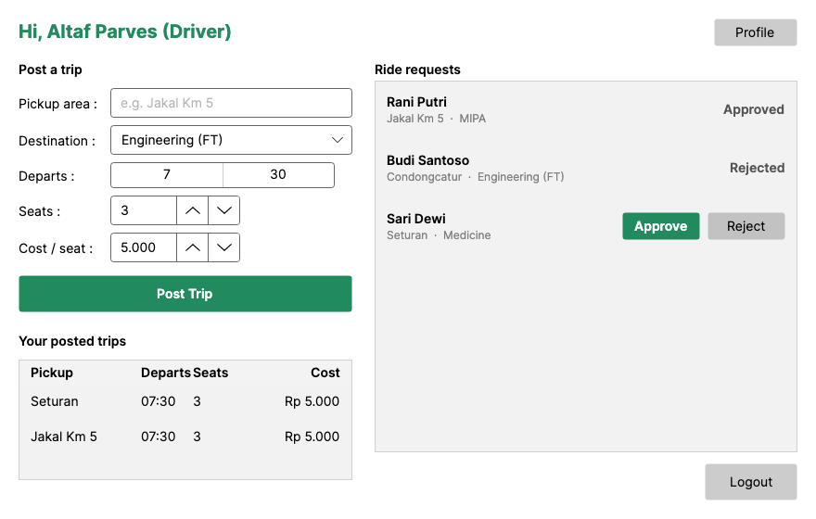
Figure 4. DriverWindow

Screen 5 - Profile
Avatar, name, NIM, role, KTM verification badge, faculty, hobbies and short bio. Save keeps the changes; Back returns to the correct home screen for the user's role.
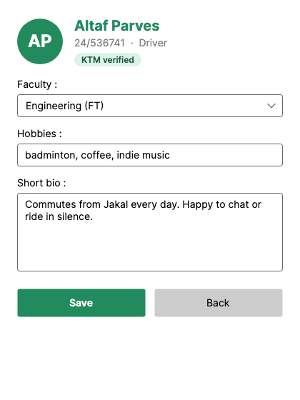
Figure 5. ProfileWindow

Navigation between forms
From | Action | Opens
Login | Login (Passenger) | Passenger Home
Login | Login (Driver) | Driver
Login | Create one | Register
Register | Register (valid) / Back | Login
Passenger Home / Driver | Profile | Profile
Profile | Back | Passenger Home or Driver (by role)
Passenger Home / Driver | Logout | Login

Source code
GitHub: https://github.com/altafparves/BarengIn - branch feature/fe/desktop-ui-prototype, folder src/BarengIn.Desktop (Avalonia) and src/BarengIn.Desktop.WinForms (Calvin's original).

